Abstract **-** Indonesia is an archipelago that has an abundance of marine biological resources with great potential for utilization. With a coral reef area of ± 51.000 ${Km}^{2}$, equivalent to 17 percent of the total area of the world's coral reefs, Indonesia is the country with the second largest coral reef area in the world. However, human activities and rising sea temperatures caused by global warming pose a major threat to the sustainability of coral reefs, where pollution and rising average sea temperatures can directly cause coral bleaching, which can lead to the mass death of coral reefs. In terms of causes, coral reef damage can be categorized into two main categories, namely damage caused by the effects of daily human activities such as coral colony mining, coral colony trading, explosive fishing in coral reef areas, fishing activities that use trawling, and other causes. While damage caused by nature is such as climate change, biological activity, the spread of disease, and the presence of predatory animals. Indonesia itself has a high risk in terms of damage to coral reefs, this is caused by overfishing using destructive tools, waste pollution, oil spills, and development that is close to the shoreline, resulting in smothering. This is evidenced by the condition of the coral reef ecosystem in the waters of Gili Matra in 2016, an increase in temperature resulted in 50% of coral colonies experiencing bleaching (coral bleaching), while 11% of coral colonies were found in pale conditions and there was coral colony mortality of 1% of coral colonies affected by bleaching. With the threat of massive damage due to environmental damage and global warming, of course, prevention efforts by means of cultivation carried out in controlled media and isolated from the open ocean are one alternative. When compared to coral reef cultivation in the open ocean, isolated coral reef cultivation in aquarium culture media has advantages in terms of control because water quality can be carefully controlled. Coral reef rehabilitation efforts through aquaculture can be done with coral transplantation methods. Coral transplantation is a method of planting and growing coral colonies by fragmenting coral colonies and then placing colony fragments in controlled cultivation media. IOT or Internet of things is a technology that is growing rapidly where through this technology it can provide convenience when a monitoring and control media is needed for a parameter, in this case the aquarium water parameter. With an Internet of things-based controller device, users can access water parameter information and control life support instruments wherever the user is.One utilization of the Internet of things is remote control.This allows users to control lighting devices anytime and anywhere, provided that the location where the controller device is used has usable and adequate internet access.

***Keyword : Coral Reefs, Coral Fragmentation, Firebase, Arduino Nano, Android, Flutte***r

1. INTRODUCTION

Indonesia is an archipelago with abundant marine biological resources with great potential for utilization[1]. One of the abundant marine biological resources spread throughout Indonesia's marine and coastal waters is coral reefs[1]. With a stretch of coral reefs ± 51,000〖Km〗^2 or 17 percent of the total area of the world's coral reefs makes Indonesia the country with the second largest stretch of coral reefs in the world [2]. Human activities and changes in sea water temperature due to global warming create a major threat to the sustainability of coral reefs, pollution and rising sea water temperatures can cause coral bleaching which can cause mass death of coral reefs [1]. Seen from the cause of coral reef damage that occurs can be grouped into two main categories, namely damage caused by human activities such as coral mining, coral trade, fish bombing in coral reef areas, fishing activities that use trawling, and others. While damage caused by nature is such as climate change, biological activity, the spread of disease, and the presence of predatory animals [3].Indonesia itself has a high risk in terms of damage to coral reefs, this is caused by overfishing using destructive tools, waste pollution, oil spills, and development close to the coastline, causing smothering [4]. This is evidenced by the condition of the coral reef ecosystem in the waters of Gili Matra in 2016, there was an increase in temperature which resulted in 50% of coral colonies experiencing coral bleaching, while 11% of coral colonies were found in pale conditions and there was coral colony mortality of 1% of coral colonies affected by bleaching [5]. The destruction of coral reefs has become a major threat to the survival of marine life and human life, with global warming, ocean acidification and environmental pollution that we cannot control the mass death of coral reefs is very likely to occur. With the threat of massive damage due to environmental damage and global warming, of course, prevention efforts by means of cultivation carried out in a controlled and isolated medium from the open ocean are one alternative. In this research, the author chose the prototyping method, which is one approach in software engineering that directly demonstrates how a software or software components will work in its environment before the actual construction phase is carried out.The prototype model is used as an indicator of the picture to be created in the future and distinguishes two functions of exploration and demonstration [6].When compared to coral reef cultivation in the open ocean, isolated coral reef cultivation in aquarium culture media has advantages in terms of control because water quality can be carefully controlled [7]. Coral reef rehabilitation efforts through aquaculture can be done with coral transplantation methods.Coral transplantation is a method of planting and growing coral colonies by fragmenting coral colonies and then placing colony fragments in cultivation media [3].The internet of things is the linkage of sensory and actuating devices that provide the ability to share data and information between platforms by utilizing internet networks to develop innovative applications [8].Internet of things (IOT) is one of the rapidly growing technologies that provides benefits in monitoring and control of aquarium water parameters [9].With an Internet of things-based controller device, users can access water parameter information and control life support instruments wherever the user is [10]. One of the utilizations of the Internet of things is remote control. This allows users to control lighting devices anytime and anywhere, provided that the location where the controller device is used has usable and adequate internet access [11]. Users will be able to control IOT devices using mobile applications on the android platform to make it easier for users to monitor and control instruments and controllers. The author hopes that the cultivation of coral reefs isolated from the open ocean can help prevent the extinction of coral species due to over-mining and climate change.

1. RESEARCH METHOD
2. Reasearch Object and Subject

The object of research is the point of attention of a study. The point of attention of this research is the design of a controller device with Arduino Nano and interface applications using Flutter SDK and Firebase. While the research subject is a group of coral reef specimens that will be observed. In this study, the subject to be observed is a group of coral colony specimens of the species Montipora Capricornis, Acropora Selago, Seriatopora Hystrix, and Dragon Eyes Zoanthids of the genus Zoanthus.

1. Research Method

This research was conducted by the author using the Prototyping method, the selection of this method is intended to assist the author in making and compiling this research report. Then the flow of the prototyping research method used is as follows:

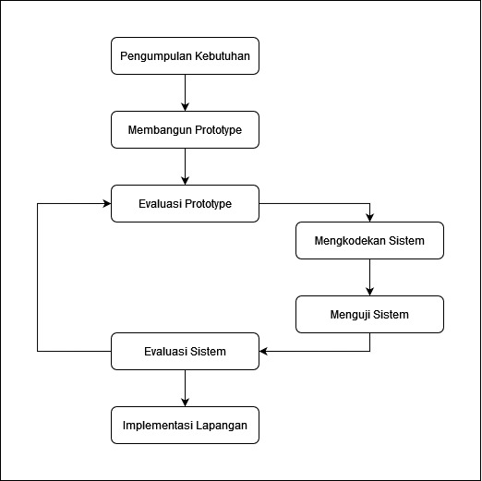

1. Hardware System Design
2. Tools

The hardware used is:

1. Acer Aspire V3-372T laptop with specifications:
2. Processor: Intel i5 6200U
3. Memory: 8 GB DDR3 RAM
4. Graphic Card: Intel HD graphics 520
5. SSD: 256 GB
6. Samsung S21 FE cellphone with specifications:
7. Chipset: Exynos 2100
8. Memory: 8 GB RAM LPDDR4
9. Storage: 356GB
10. Network: 4G LTE
11. Visual Studio Code with specifications:
12. Version: 1.74.2
13. Windows 10 Pro with specifications:
    1. Architecture: 64 bit
14. One UI 5.0 with specifications:
15. Android Version : Android 13
16. Arduino IDE with specifications:
17. Version: 1.8.17.0
18. Adobe XD with specifications:
    1. Version: 39.0.12.12
19. Fritzing with specifications:
    1. Version: 0.9.2.b
20. AutoCAD 2021 English with specifications:
    1. Version: AC1032

2. Materials

The materials used are:

1. Microcontroller Arduino Nano v3 with specifications:
2. Microcontroller: ATmega 3282)Memory:2KB SRAM3) Storage: 32KB Flash Memory4) Operating Voltage: 5v5)PWM pins:6 pinsb) Coral Reef Cultivation Media with specifications:
3. Aquarium: Dimensions 130 cm x 45 cm x 45 cm
4. Water Source:Natural Sea Water3) Filtration System: Multi Chamber Sump Filter
5. Return Pump:Armada AM-105B 4000LPH5) Anaerobic Nitrate Reactor
6. Espressif ESP8266 Network Module with specifications: Network: 2.4 GHz Wi-Fi (802.11 b/g/n, supporting WPA/WPA2)2)CPU:Tensilica Xtensa L1063) Operating Voltage: 3.3v

d) Kamoer Peristaltic Pump NKP-DC-S06D with specifications:1) c) Espressif ESP8266E Network Module with specifications:1) Network:2.4 GHz Wi-Fi (802.11 b/g/n, supporting WPA/WPA2)2)CPU:Tensilica Xtensa L1063)Operating Voltage:3.3vd) Kamoer Peristaltic Pump NKP-DC-S06D with specifications:1)Working Voltage: 12 Volts

2) Flow Range: 5.2ml/min to 90ml/min

e) Artificial Lighting Device with specifications:

1) Working Voltage: 12 Volt - 36 Volt

2) Light Emitter: Light Emmiting Diode

3) Light Spectrum Range: 450nm - 660nm

1. Optical Lens Angle: 45º - 120º
2. Power consumption: 80 Watts
3. Heat Dissipation: Aluminum Heatsink Single fan
4. DCP002 Current Making Pump with specifications:Working Voltage: 12 Volts
5. Flow Range: 400LPH - 1000LPH
6. Tiny RTC DS1307 Time Module with specifications:Working Voltage: 5 Volts

Communication Protocol: I2C Protocol

1. Result

This chapter is a continuation of the design, namely implementation, testing, and discussion of evaluations of prototype tools that have been assembled and coded. At this stage the author will evaluate the design, build a hardware system prototype and build a software system prototype.

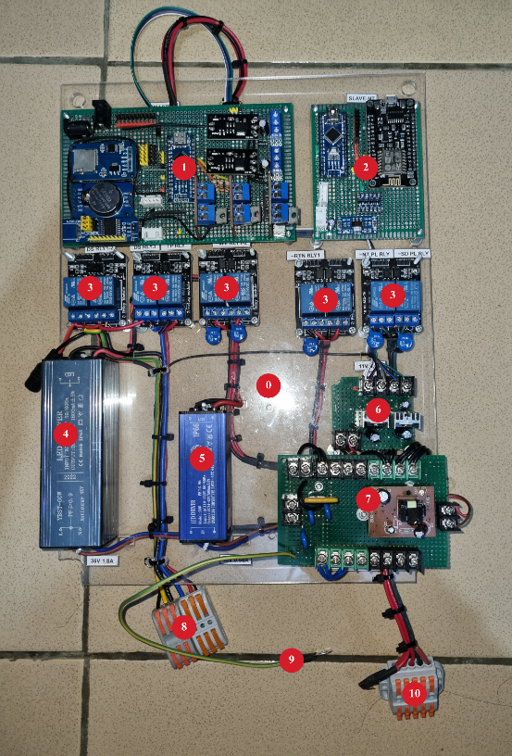

Fig 1. Controller device

The master controller board is built with a common ground star topology to minimize the occurrence of noise and EMI from each connected work component. While the power lines (5v and GND) for relay control power have been isolated from the main power lines shown at points 2 and 6 in Figure 4.7, this is intended to avoid unwanted interference from the effect of the relay induction load itself.

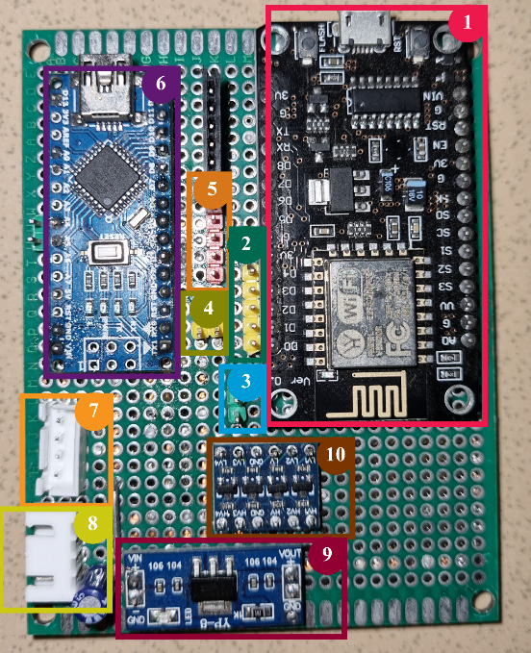

Fig 2. Controller slave device

In the slave controller there is a Node MCU development module, based on the ESP8266EX microcontroller which is a development version of the ESP8266, this microcontroller is used as a network endpoint and relay control of network status indicator lights. arduino nano sensor side microcontroller which has a function to read the sensor and control the activation of the top up pump relay and aquarium cooling fan.

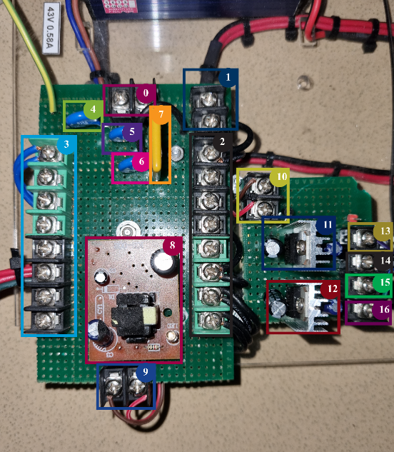

Fig 3. Power delivery board

Board for power delivery with overcurrent protection and overvoltage protection using PPTC and MOV, it provides the system a working current 230v, 12v, and 5vdc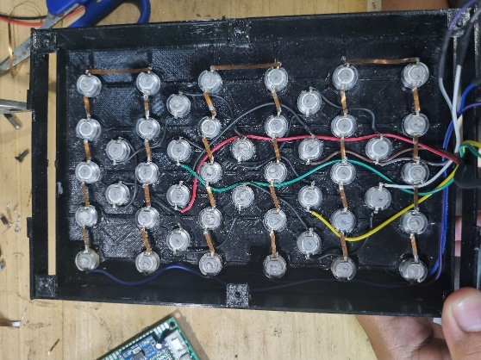

Fig 4.photosythetic lamp

The photosynthesis lamp uses PETG plastic for the casing made using 3D printing technology, 2 6cm x 6cm cooling fans, an aluminum heatsink, and 44 HPL LED emitters.

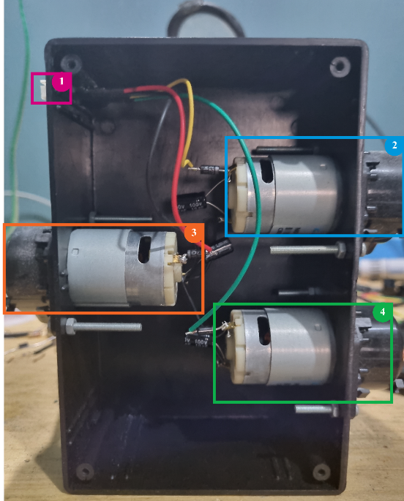

Fig 5.Dosing pump

The peristaltic pump circuit is protected by using a plastic casing, rectification diodes, voltage stabilizing capacitors, and using an XH 2.54 connector as a power connection.

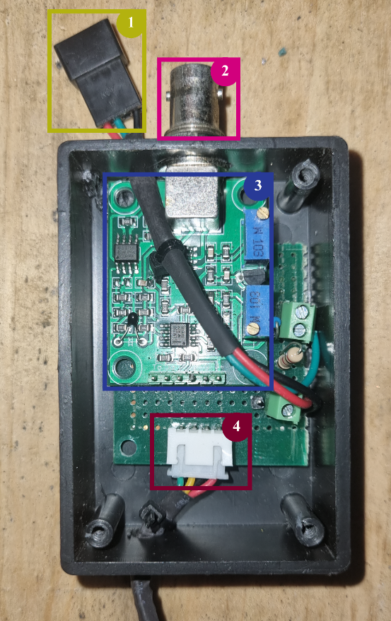

Fig 5.Sensor Sub board

The secondary board circuit houses the PH 4502C board and a pull-up resistor for the DS18B20 temperature sensor output.

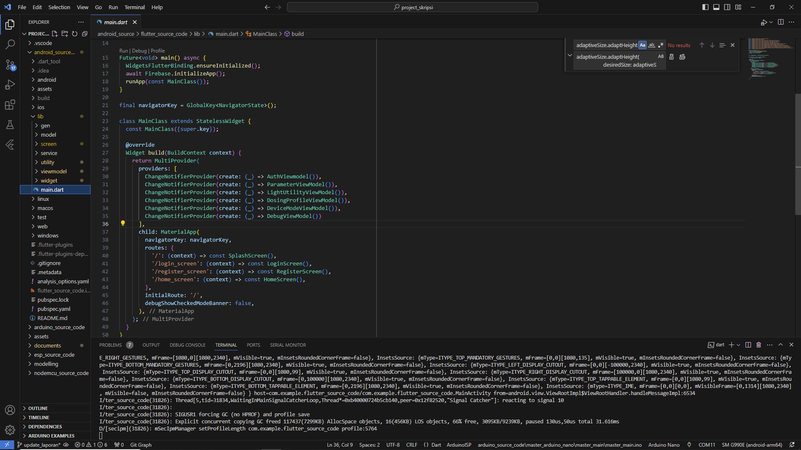

Fig 6.Android apps development

The firebase firestore system is used as a data logger that records sensor readings, water parameter readings from user input, and records the amount of supplementation that has been given. The Android-based monitoring and control application was created using the Flutter Software Development Kit using the Visual Studio code IDE. The application is built with MVVM architecture or Model, View, ViewModel and Provider as state management.

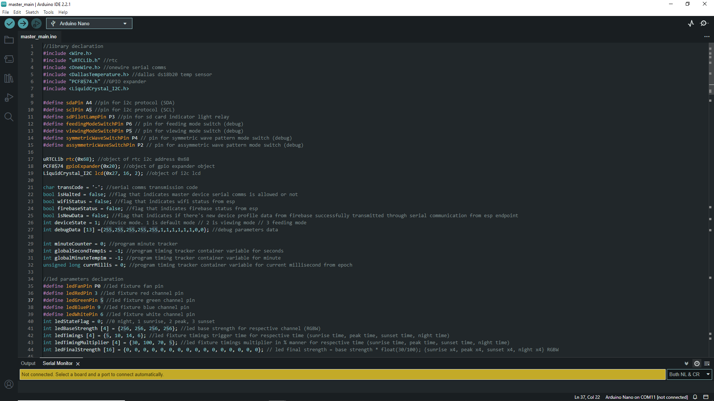

Fig 7 arduino software development

The embedded software is created using the c++ language with the Arduino IDE, there are 3 source codes created for each microcontroller.

1. DISCUSION

At this stage the prototype product that has been made will be tested using the blackbox testing method which will test several aspects of the entire controller system. Application testing was carried out using the One UI operating system based on Android 13 on a device with the Samsung S21 FE model and an indihome internet network with a speed of 25Mbps - 40Mbps. Connect the ESP8266 Node MCU network endpoint slave controller with a wifi network and firebase server.

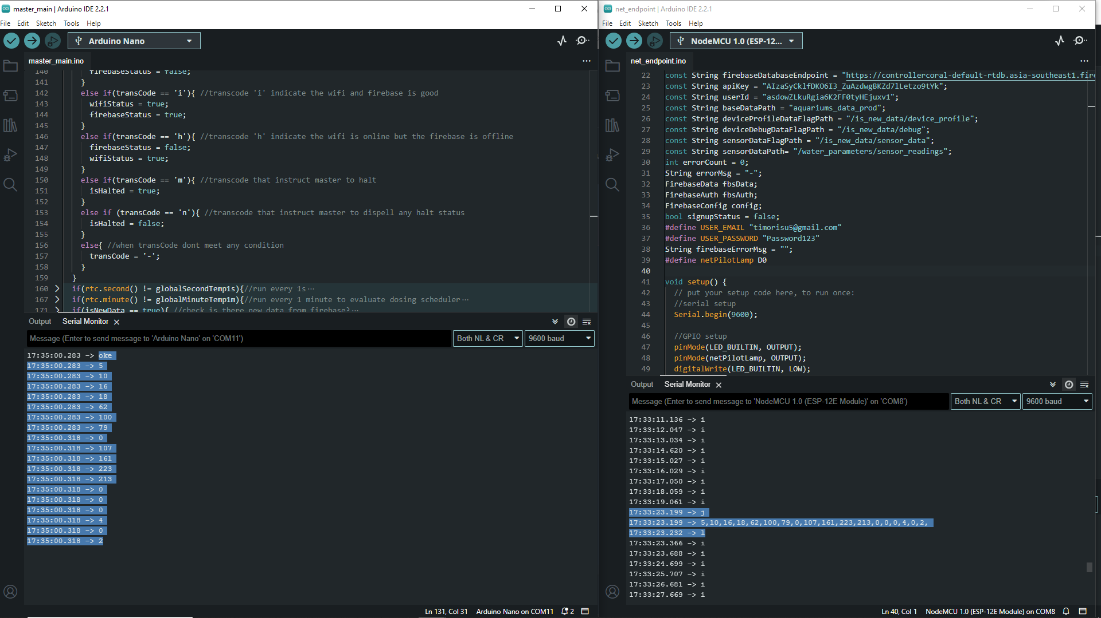

Fig 8 Testing communication

Communication between the NodeMCU network endpoint and the Arduino nano v3 master controller via serial communication protocol.

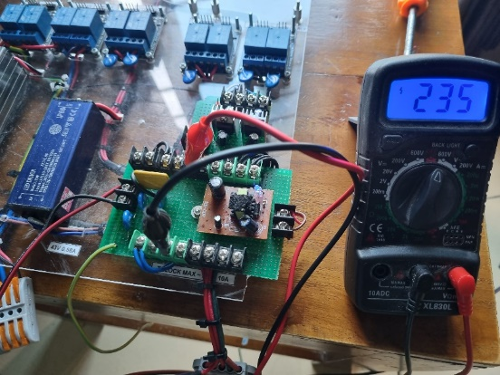

Fig 9 Testing power delivery

Tests were carried out using avometer and testpen voltage test equipment to test the voltage magnitude and orientation of the power line on the part of the power provider and the input voltage of the 1 phase 220v - 250v PLN voltage.

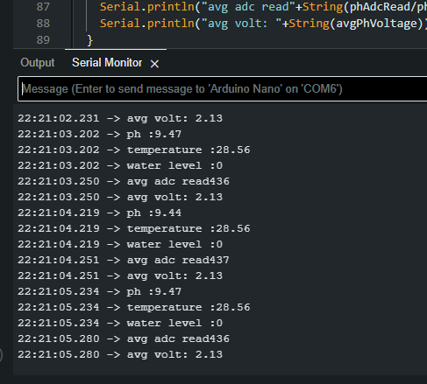

Fig 10 Testing sensor reading

Testing of sensor devices is done by testing each sensor with test media that is already known to the test magnitude.

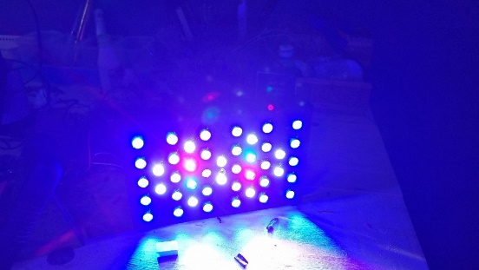

Fig 11 Testing photosynthetic lamp

Testing is done by applying working voltage to each channel of the photosynthesis lamp circuit and ensuring the cooling fan is working properly.

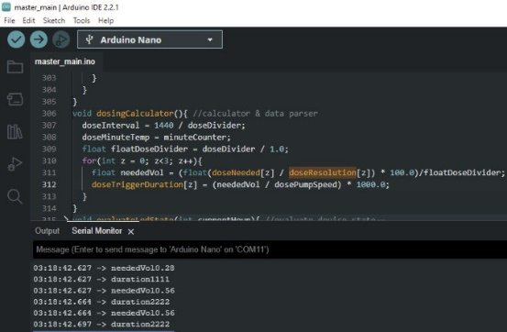

Fig 12 Testing dosing system

The test was conducted by looking at the active duration in milliseconds of each pump channel with an offset as a pause between channels, the active duration dT was determined using the formula:

With:

dT = active duration (s)

a = dose (solution concentration)

b = concentration of supplement solution (concentration/volume)

c = divisor

Q = pump speed (ml/s)

dT=((a/b)x (100/c))/Q x 1000

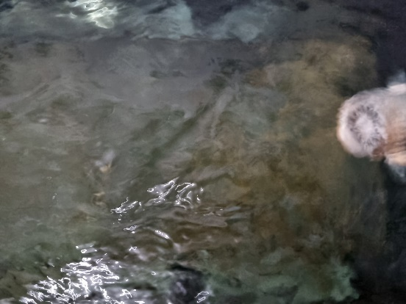

Fig 13 Testing wavemaker system

Testing is done by looking at the schedule and duration of current pump activation.

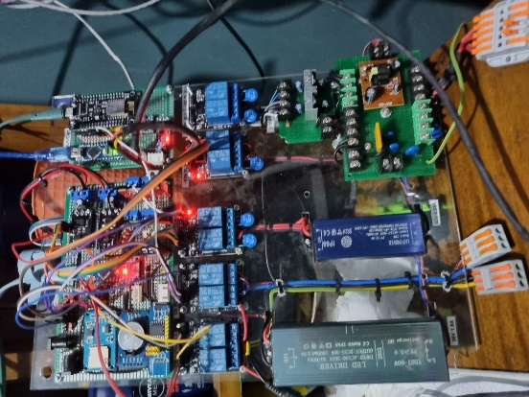

Fig 14 Testing auto top up system

Testing is done by looking at the response of the top up pump relay to changes in the state of the height sensor.

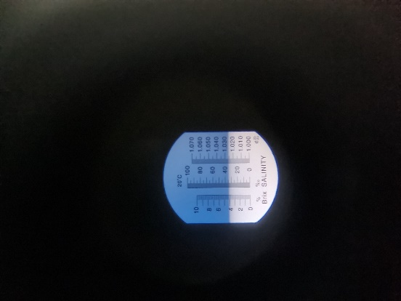

Fig 15 Testing salinity

The test is carried out by taking a sample of media water and using a refractometer to find the salinity value of the water sample.

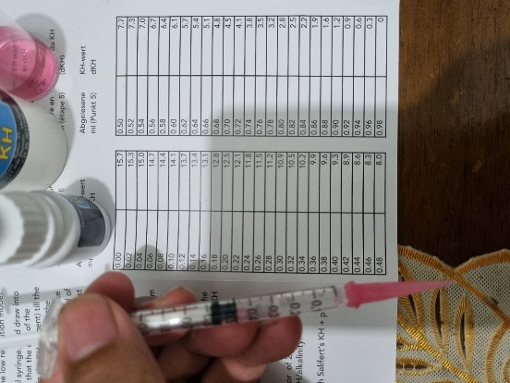

Fig 16 Testing water chemistry

Testing is done through the titration test method using salifert test kit products.

By reviewing 12 prototype product test results, 11 tests met the problem limits and deviation limits with a note that the magnesium content of the media water needs to be increased by increasing the dose of magnesium supplementation in the media water.

1. CONCLUSION

Based on the results of the study, it can be concluded that the design of a coral reef cultivation media controller with arduino nano v3 and flutter sdk has been successfully carried out. This can be concluded from the results of testing life support instruments that are able to meet and maintain the basic conditions and requirements of life for coral reef biota.

REFERENCES

[1] D. Salim, “Pengelolaan ekosistem terumbu karang akibat pemutihan (bleaching) dan rusak,” *J. Kelaut.*, vol. 5, no. 2, pp. 142–155, 2012.

[2] M. Kasmi, A. Asriany, A. R. Makkulawu, and A. F. Usman, “Peningkatan Pengelolaan Budidaya Karang Hias Lestari Berbasis Masyarakat,” *J. Balireso J. Pengabdi. pada Masy.*, vol. 5, no. 2, pp. 109–123, 2020.

[3] Z. Zulfikar and D. Soedharma, “Teknologi Fragmentasi Buatan Karang (Caulastrea furcata dan Cynarina lacrimalis) dalam Upaya Percepatan Pertumbuhan pada Kondisi Terkontrol,” *J. Natur Indones.*, vol. 10, no. 2, p. 76, 2012, doi: 10.31258/jnat.10.2.76-82, 2008.

[4] A. R. Rubianto, “Fasilitas Penelitian Dan Budidaya Terumbu Karang Di Tanjung, Lombok Utara,” *eDimensi Arsit. Petra*, vol. VII, no. 1, pp. 857–864, 2019, [Online]. Available: http://publication.petra.ac.id/index.php/teknik-arsitektur/article/view/9350%0Ahttp://publication.petra.ac.id/index.php/teknik-arsitektur/article/download/9350/8429.

[5] F. Setiawan *et al.*, “Dampak Pemutihan Karang Tahun 2016 Terhadap Ekosistem Terumbu Karang: Studi Kasus Di TWP Gili Matra (Gili Air, Gili Meno dan Gili Trawangan) Provinsi NTB Coral Bleaching Impact in 2016 Towards Coral Reef Ecosystem: Case Studies TWP Gili Matra (Gili Air,” *J. Kelaut. Indones. J. Mar. Sci. Technol.*, vol. 10, no. 2, p. 147, 2018, doi: 10.21107/jk.v10i2.2878.

[6] S. Siswidiyanto, A. Munif, D. Wijayanti, and E. Haryadi, “Sistem Informasi Penyewaan Rumah Kontrakan Berbasis Web Dengan Menggunakan Metode Prototype,” *J. Interkom J. Publ. Ilm. Bid. Teknol. Inf. dan Komun.*, vol. 15, no. 1, pp. 18–25, 2020, doi: 10.35969/interkom.v15i1.64.

[7] E. E. Barus, R. K. Pingak, and A. C. Louk, “Otomatisasi Sistem Kontrol Ph Dan Informasi Suhu Pada Akuarium Menggunakan Arduino Uno Dan Raspberry Pi 3,” *J. Fis. Fis. Sains dan Apl.*, vol. 3, no. 2, pp. 117–125, 2018, doi: 10.35508/fisa.v3i2.612.

[8] I. N. B. Hartawan and I. W. Sudiarsa, “Analisis Kinerja Internet of Things Berbasis Firebase Real-Time Database,” *J. Resist. (Rekayasa Sist. Komputer)*, vol. 2, no. 1, pp. 6–17, 2019, doi: 10.31598/jurnalresistor.v2i1.371.

[9] D. Y. Tadeus, K. Azazi, and D. Ariwibowo, “Model Sistem Monitoring pH dan Kekeruhan pada Akuarium Air Tawar berbasis Internet of Things,” *Metana*, vol. 15, no. 2, pp. 49–56, 2019, doi: 10.14710/metana.v15i2.26046.

[10] R. K. Putra Asmara, “Rancang Bangun Alat Monitoring Dan Penanganan Kualitas Ait Pada Akuarium Ikan Hias Berbasis Internet Of Things (IOT),” *J. Tek. Elektro dan Komput. TRIAC*, vol. 7, no. 2, pp. 69–74, 2020, doi: 10.21107/triac.v7i2.8148.

[11] R. Muzawi, Y. Efendi, and W. Agustin, “SATIN – Sains dan Teknologi Informasi Sistem Pengendalian Lampu Berbasis Web dan Mobile Rometdo Muzawi,” *Sains dan Teknol. Inf.*, vol. 4, no. 1, pp. 29–35, 2018.

[12] H. K. Mauli Kasmi, Asriany, Andi Ridwan Makkulawu, Arif Fuddin Usman, “Aplikasi Teknologi Pengembangan Budidaya Karang Hias Lestari Sebagai Mata Pencaharian Alternatif di Pulau Barrang Lompo Makassar , Sulawesi Selatan Application of Development Technology for Sustainable Ornamental Corals Aquaculture as Alternative Income I,” *J. Panrita_Abdi*, vol. 5, no. 3, pp. 432–446, 2021, [Online]. Available: http://journal.unhas.ac.id/index.php/panritaabdi.

[13] E. S. Rahayu, L. Listanto, and R. Diharja, “Rancang Bangun Perangkat *Wearable* Pemantau Kondisi Kesehatan di Masa Pandemi Covid-19,” *J. Media Inform. Budidarma*, vol. 6, no. 3, p. 1630, 2022, doi: 10.30865/mib.v6i3.4195.

[14] Suryanti, Supriharyono, and W. Indrawan, “Kondisi Terumbu Karang dengan Indikator Ikan Chaetodontidae di Pulau Sambangan Kepulauan Karimun Jawa, Jepara, Jawa Tengah.,” *Bul. Oseanografi Mar.*, vol. 1, pp. 106–119, 2011.

[15] R. Djamaluddin, J. I. Paransa, and Hatidja Djoni, “Rignolda Djamaluddin Riset Terapan Unggulan Unsrat,” p. 3, 2019.

[16] T. . Hadi, Giyanto, B. Prayudha, M. Hafizt, A. Budiyanto, and Suharsono, *Indonesia coral reef status 2018*. 2019.

[17] E. Orlando and Y. I. Chandra, “Penerapan Metode Prototype Dalam Membuat Alat Penyiraman Tanaman Otomatis Berbasis Mikrokontroler Arduino Uno,” vol. 23, no. 2, pp. 9–23, 2022.

[18] A. Surahman, B. Aditama, and M. Bakri, “Sistem Pakan Ayam Otomatis Berbasis Internet of Things,” *Jtst*, vol. 02, no. 01, pp. 13–20, 2021.

[19] Y. Efendi, “Internet Of Things (Iot) Sistem Pengendalian Lampu Menggunakan Raspberry Pi Berbasis Mobile,” *J. Ilm. Ilmu Komput.*, vol. 4, no. 1, pp. 19–26, 2018, doi: 10.35329/jiik.v4i1.48.

[20] C. Khawas and P. Shah, “Application of Firebase in Android App Development-A Study,” *Int. J. Comput. Appl.*, vol. 179, no. 46, pp. 49–53, 2018, doi: 10.5120/ijca2018917200.

[21] E. Haryanto, M. Arif, and M. Setiawan, “Perancangan Sistem Informasi Pembelajaran Praktikum Online Multiplatform Berbasis Framework Flutter,” *Pros. Semin. Nas. …*, 2021, [Online]. Available: http://e-journal.janabadra.ac.id/index.php/PSN/article/viewFile/1568/1040.

[22] D. A. Afit Muhammad Lukman, “Aplikasi mobile memiliki user interface dengan mekanisme interaksi unik yang disediakan oleh platform mobile . Aplikasi mobile juga telah dirancang khusus untuk platform mobile ( misalnya IOS , android , atau windows mobile ).,” *Evolusi*, vol. 7, no. 2, pp. 58–65, 2019.

[23] L. Safitri *et al.*, “Analisa Dan Perancangan Sistem Informasi Text Chatting Berbasis Android Web View,” *Molecules*, vol. 2, no. 1, pp. 1–12, 2020.

[24] H. Prabowo and F. Arifin, “Pengembangan Media Pembelajaran Kendali Fuzzy Logic Berbasis Arduino Nano Pada Mata Kuliah Praktik Sistem Kendali Cerdas,” *Elinvo (Electronics, Informatics, Vocat. Educ.*, vol. 3, no. 1, pp. 39–45, 2018, doi: 10.21831/elinvo.v3i1.19739.

[25] W. N. Cholifah, Y. Yulianingsih, and S. M. Sagita, “Pengujian Black Box Testing pada Aplikasi Action & Strategy Berbasis Android dengan Teknologi Phonegap,” *STRING (Satuan Tulisan Ris. dan Inov. Teknol.*, vol. 3, no. 2, p. 206, 2018, doi: 10.30998/string.v3i2.3048.